# VLSI Lab 2 – Padframe

Matthew Murray – 873525242

## Schematic

### Pad cell

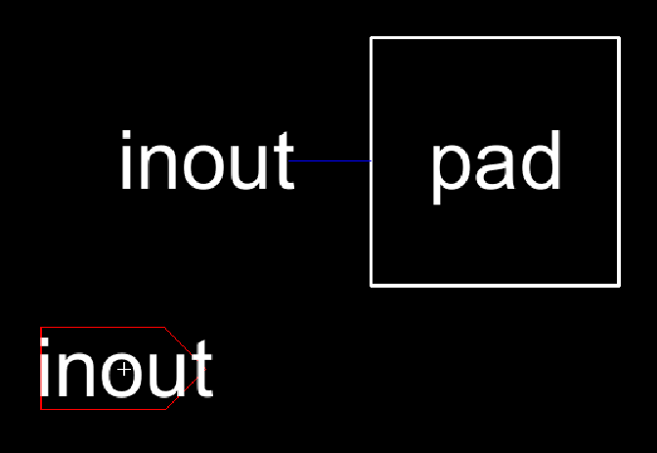

### DAC

Padframe was made with 8 pins since it’s a 2x2 package but DAC only needs 7 pins so the extra pin is connected to ground.

### Padframe

## Layout

Routing was done entirely on metal 2 to be able to go over the wiring within the DAC itself.